**Web Design 1**

**Final Project Planning**

**Design brief for website design.  
10/20/2029  
Prepared by Julee West**

**Website Content:**

**  
Header image.**

**Homepage:   
**

**Logo for header.  
• Header:**

* **Logo (JASYP)**
* **Navigation Menu: Home | About JASYP | Partners| Register | Resources| Register**
* **Call to Action Button: "Register Now" or "Become a Sponsor"**

**• Hero Section:**

* **Main CTA: "Join the Japanese Job Fair 2025"**
* **Subtitle: Date, Location, and Event Highlight**
* **Two prominent buttons: "Register" and "Sponsor Us"**

**• About the Event (Short Blurb):**

* **What the event is about (connecting Japanese-speaking professionals with companies)**

**• Sponsors Spotlight (Optional):**

* **Logos or names of key sponsors**

**• Footer:**

* **Social media links, quick links, contact information, copyright**

**About JASYP (page):**

* **Section 1: Mission and Vision:**
  + **Brief introduction of JASYP’s mission (developing young professionals, fostering cross-cultural connections)**
* **Section 2: The Team:**
  + **Meet the executive team or founder section with short bios and photos (optional)**
* **Section 3: Past Events (optional)**

**Partners (page):  
Section 1:**

**• Section of Sponsors at top.  
• Section 1: Why Sponsor:**

* **Benefits of sponsoring the Japanese Job Fair (exposure to bilingual talent, networking with potential employees)**

**• Section 2: Sponsorship Tiers:**

* **Table showing different sponsorship levels (e.g., Gold, Silver, Bronze)**
* **What each level includes (e.g., table at the event, banner placement, social media shoutouts)**

**• Section 3: Sponsor Testimonials:**

* **Quotes from companies that have sponsored in the past, if available**

**• Section 4: How to Become a Sponsor:**

* **Clear instructions and contact form or button to inquire about sponsorship opportunities**

**Register (page):**

**• Section 1: Register for the Event:**

* **Registration form for job seekers (link google form)**

**• Section 2: What Attendees Can Expect:**

* **A brief overview of activities (job fairs, networking, skill-building workshops, etc.)**
* **Things to bring (business casual wear, resumes, business cards)**

**Resources (page):**

**• Section 1: Interview & Resume Tips:  
• Section 2: Useful Phrases:**

**Wireframes:  
Home Page:  
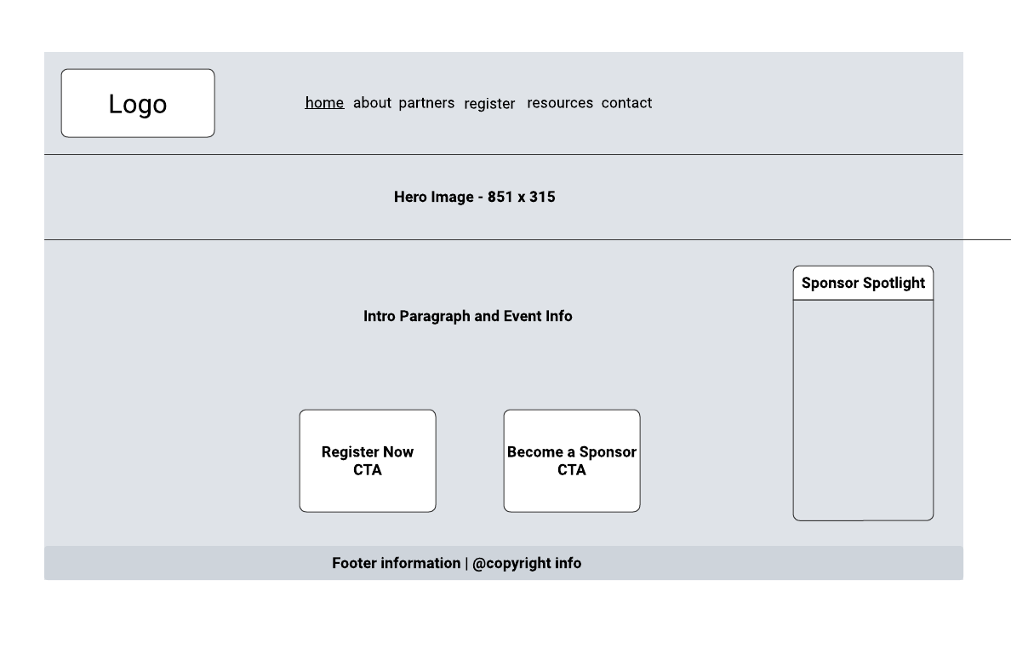**

### Website look and feel: **Colors:** **Space Cherry #990011FF,**

### **White #FCF6F5FF Charcoal Gray (#4A4A4A)**

### **Medium Gray (#C4C4C4**

**)

The goal is to create a refined, subtle, clean look, only utilizing reds to create contrast and stick out. The white and red is also associated with the colors of the Japan flag.

**Fonts**

*Yu Gothic:*

Yu Gothic is often used in Japanese web and print design. It’s versatile and gives a professional yet welcoming feel, making it ideal for a job fair.  
Use: Japanese and English text, especially headings and main content.  
Available on most Windows 8-11

font-family: 'Yu Gothic', sans-serif;

*Roboto: (Google Fonts)*

Roboto is a neutral style, but slightly more modern. Easily readable and I believe it will compliment Yu Gothic well without too much classing  
**Use**: Primary menu items or navigation links, call-to-action buttons.  
Head Link: <link href="https://fonts.googleapis.com/css2?family=Doto:wght@100..900&family=Noto+Sans+JP:wght@100..900&family=Roboto:ital,wght@0,100;0,300;0,400;0,500;0,700;0,900;1,100;1,300;1,400;1,500;1,700;1,900&display=swap" rel="stylesheet">

font-family: 'Roboto', sans-serif;

Final Site Objectives:

1. Increase participation.
2. Increase sponsorship.
3. More awareness of event and groups
4. Educate those interested in pursuing Japanese

Target Audience:

There are multiple target groups, income level has little to do with it.  
Everyone interested will either know Japanese at some level or will want to – Consider adding Japanese to the Pages.  
  
-students with an interest in Japan, wanting to find a career during or after graduation.  
-non-student job seekers. Also, an interest in Japan looking for new employment opportunities.  
-Japanese company owners in the area that would benefit from these employees in their company, or benefit from networking with other Japanese companies.  
-Other organizations in Michigan related to the Japan-interested community.   
Because there is an implication of a professional event, it is implied people with some level of education or experience will be the ones interested in this event.   
  
Overall Assessment: Website should be concise yet informational and easy to navigate. Should be attractive to the eyes but not exceptionally stylized.  
Should consider adding Japanese information when possible, and Japanese-English phrases.   
  
Registration Link should be put throughout the pages.